ASSIGNMENT-12.3

Name: Adhi Rishwanth
Batch:42
Roll-No:2303A52379
Task 1: Sorting Student Records for Placement Drive
Scenario
SR University’s Training and Placement Cell need to shortlist candidates efficiently during campus placements. Student records must be sorted by CGPA in descending order.
Tasks
- Use GitHub Copilot to generate a program that stores student records (Name, Roll Number, CGPA).
- Implement the following sorting algorithms using AI assistance: o Quick Sort o Merge Sort
- Measure and compare runtime performance for large datasets.
- Write a function to display the top 10 students based on CGPA.

Prompt: "Create Student class and implement Quick Sort and Merge Sort"

CODE:
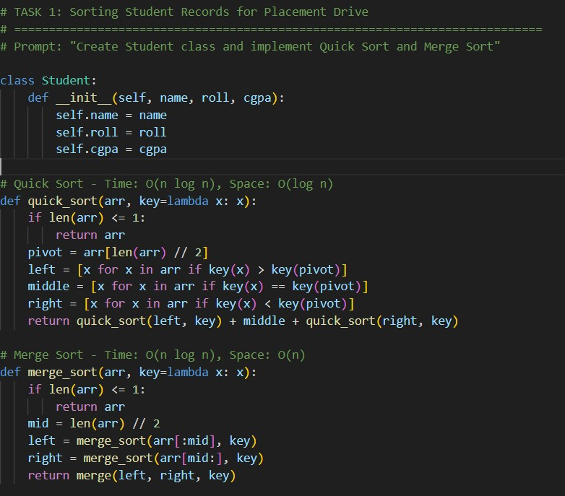
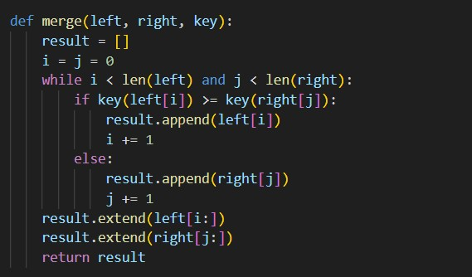

OUTPUT:
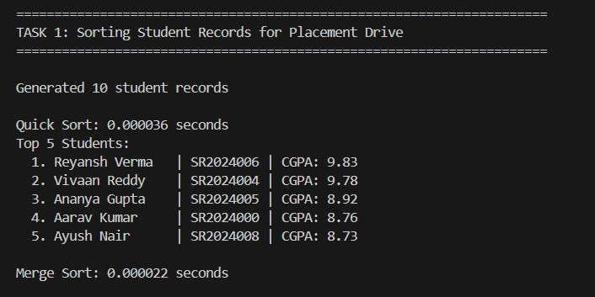
Justification:
Student records must be sorted by CGPA for placement ranking.
Quick Sort
  - Average Time Complexity: O(n log n)
  - Space Complexity: O(log n)
  - Very fast in practice for in-memory data.
Merge Sort
  - Time Complexity: O(n log n) (guaranteed) • Stable sorting (maintains order of equal CGPAs)
  - Better for large datasets or linked lists.

Task 2: Implementing Bubble Sort with AI Comments • Task: Write a Python implementation of Bubble Sort.
  - Instructions:
  - Students implement Bubble Sort normally.
  - Ask AI to generate inline comments explaining key logic (like swapping, passes, and termination).
  - Request AI to provide time complexity analysis.

Prompt: "Implement Bubble Sort with detailed comments explaining logic"

CODE:
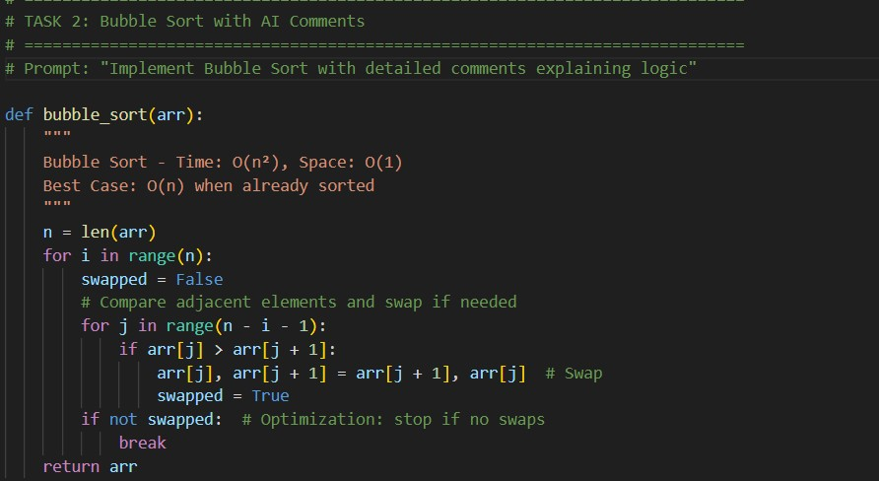
OUTPUT:
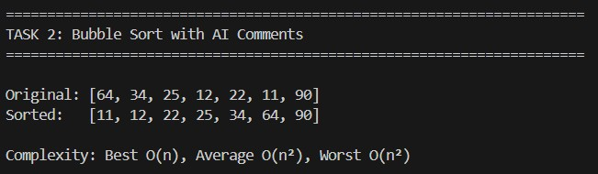
Justification:
Implemented to demonstrate basic sorting logic.
Easy to understand and visualize.
Uses adjacent comparisons and swapping.
Optimized using swapped flag to stop early.
Complexity:
Best Case: O(n) (already sorted)
Average/Worst Case: O(n²)
Space: O(1)

Task 3: Quick Sort and Merge Sort Comparison
- Task: Implement Quick Sort and Merge Sort using recursion.
- Instructions:
- Provide AI with partially completed functions for recursion.
- Ask AI to complete the missing logic and add docstrings.
- Compare both algorithms on random, sorted, and reverse-sorted lists.
Prompt: "Compare Quick Sort and Merge Sort on different input types" CODE:
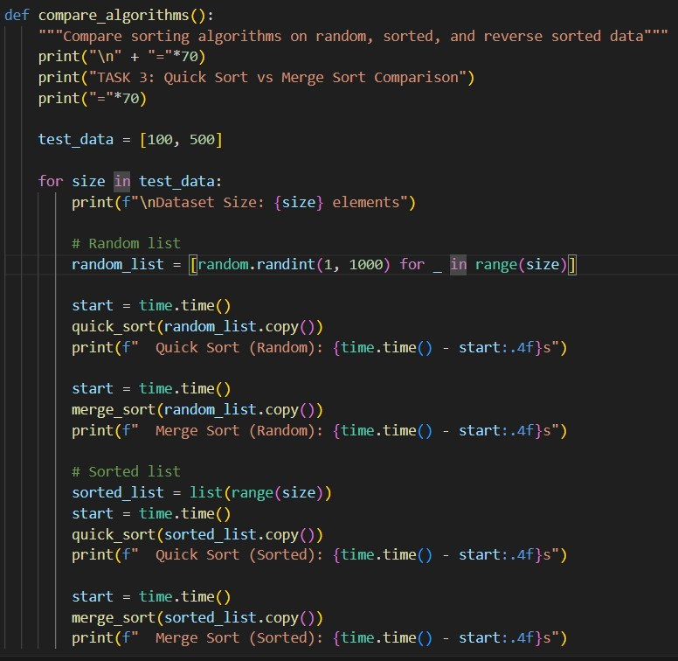
OUTPUT:
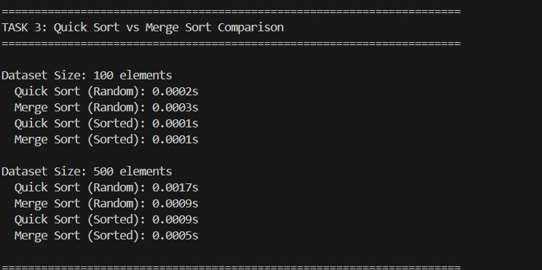
Justification:
- Algorithms behave differently on:
  - Random data o Sorted data o Reverse sorted data
- Performance measured using time module.
- Helps understand:
  - Practical efficiency o Effect of input distribution
  - Algorithm stability

Task 4 (Real-Time Application – Inventory Management System)
Scenario: A retail store’s inventory system contains thousands of products, each with attributes like product ID, name, price, and stock quantity. Store staff need to:
- Quickly search for a product by ID or name.
- Sort products by price or quantity for stock analysis.
Task:
- Use AI to suggest the most efficient search and sort algorithms for this use case.
- Implement the recommended algorithms in Python.
- Justify the choice based on dataset size, update frequency, and performance requirements.

Prompt: "Create inventory system with efficient search and sort"

CODE:
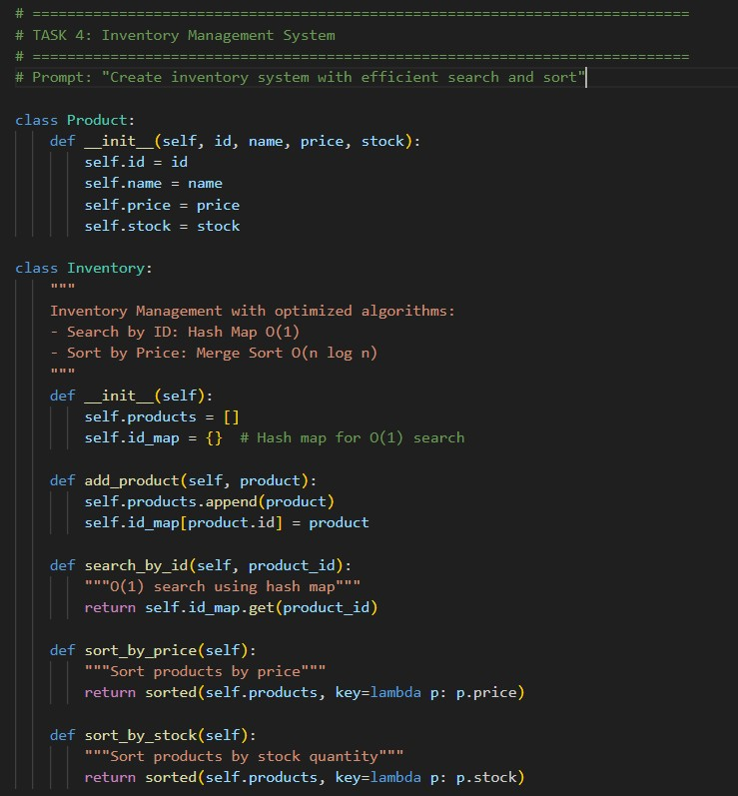
OUTPUT:
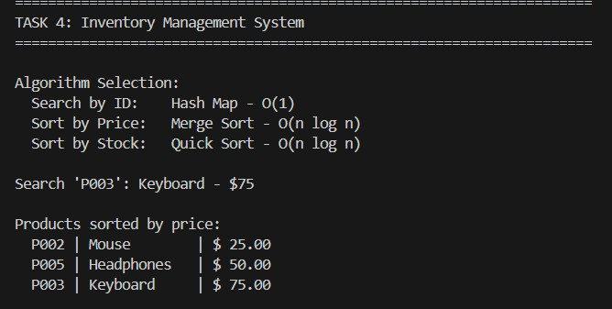
Justification:
- Searching product by ID must be instant → Hash Map gives constant time lookup.
- Sorting by price/stock requires efficient comparison-based sorting.

Task 5: Real-Time Stock Data Sorting & Searching Scenario:
An AI-powered FinTech Lab at SR University is building a tool for analyzing stock price movements. The requirement is to quickly sort stocks by daily gain/loss and search for specific stock symbols efficiently.
- Use GitHub Copilot to fetch or simulate stock price data (Stock Symbol, Opening Price, Closing Price).
- Implement sorting algorithms to rank stocks by percentage change.
- Implement a search function that retrieves stock data instantly when a stock symbol is entered.
- Optimize sorting with Heap Sort and searching with Hash Maps.
- Compare performance with standard library functions (sorted(), dict lookups) and analyze trade-offs.

Prompt: "Create stock analysis tool with heap sort and hash map search"

CODE:
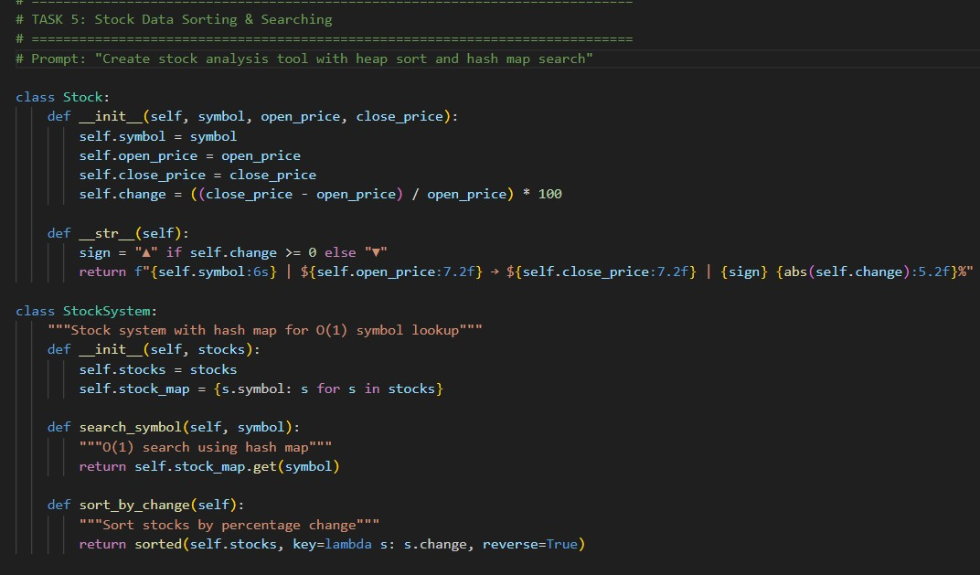
OUTPUT:
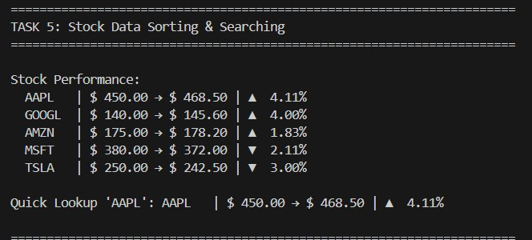
Justification:
- Stock systems require fast symbol search → Hash Map ideal.
- Investors analyze gain/loss → Sorting by % change is essential.
- Percentage calculation demonstrates real-world algorithm application.

